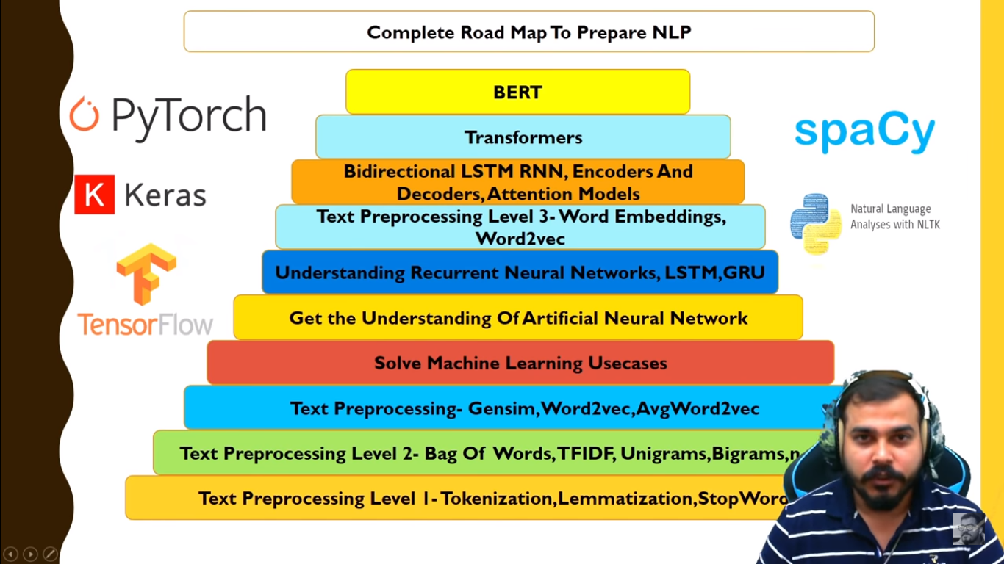

# Text processing level 1

<https://colab.research.google.com/drive/13waQu9mcUM0LyYoSfOUb2JmpUnM4m3vf#scrollTo=GqUW9lOrecV_>

## Stemming

: reducing the word to the word stem

History and historical reduced to histori

Final ,finally,fanalizer : fina

## Lemmatization

: it convert word onto meaningful word

History and historical reduced to history

Final ,finally,fanalizer : final

Hence we can say that in some cases stemming won’t give a meaningful representaion of word

And lemmatization is lengthy process

Stemming can be used when we are suppose focuse on occurance of the word and meaning is not that important

# Text processing 2

## Bag of words

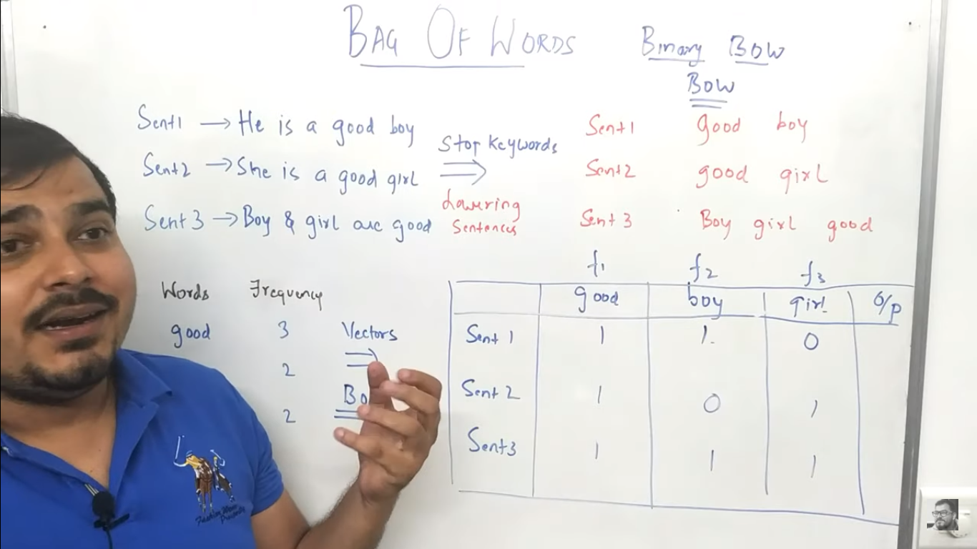

Disadvantage the value of good and boy remains same this wont help in sentimental alalysis as we know the good word is important than boy henc we need TFIDF or Word2vec

<https://www.youtube.com/watch?v=D2V1okCEsiE&list=PLZoTAELRMXVMdJ5sqbCK2LiM0HhQVWNzm&index=8>

## TF-IDF

Term frequency Inverse document frequency

TF = no. of a words in a sentence / no. of words in that sentence

IDF = no. of sentences / no. of sentence containing that word

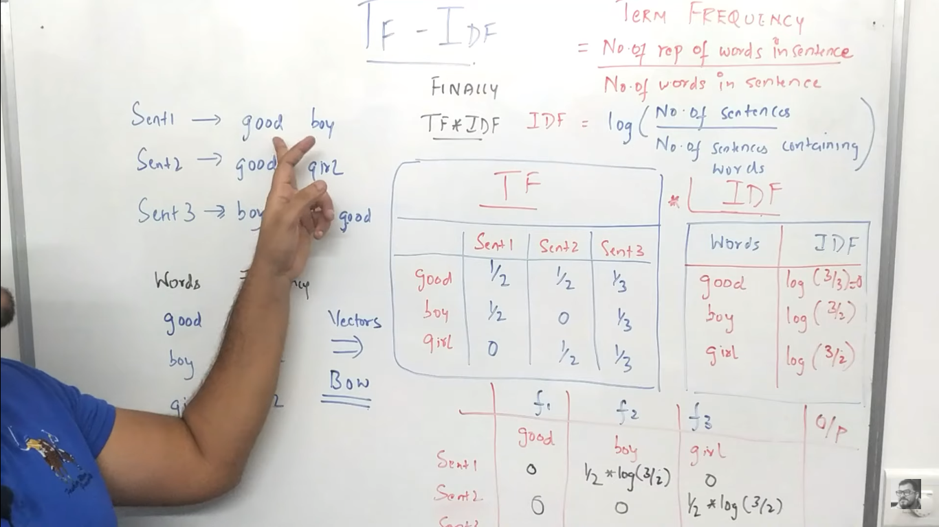

`And multi ply TF with IDF

Now this will give value in decimal and we can find which word is important

Spam Classifier

https://colab.research.google.com/drive/1b-uLx1jocZNvfCLxtC40Jex130iUfc0b

## Word2Vec

There are drawback with TFIDF and bagof words that there is no symentics and there is overfitting

Here each word is converted into 32 or more dimensions

And we can keep semantic

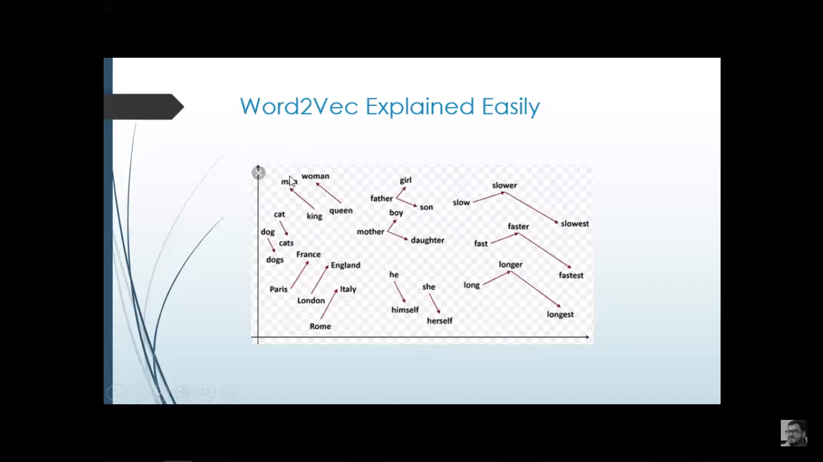

# Neural Network

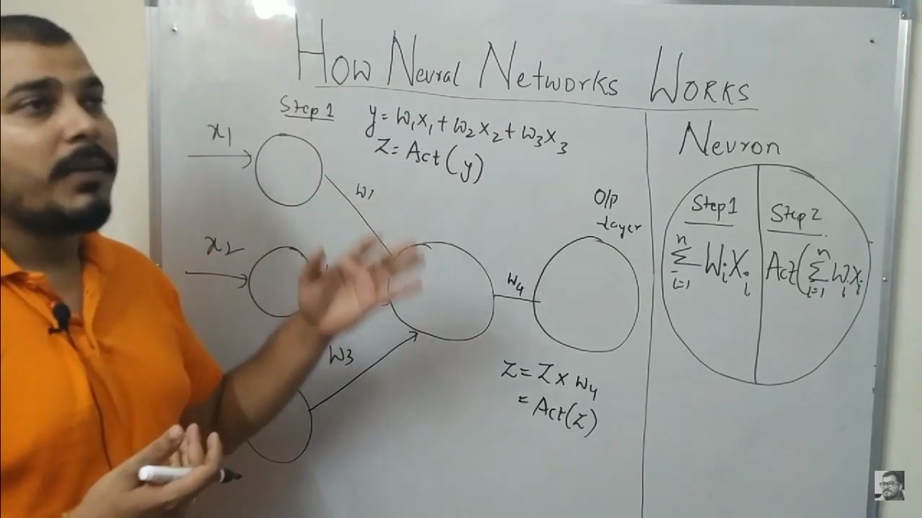

Y = w1 x1 + w2x2 + w3x3

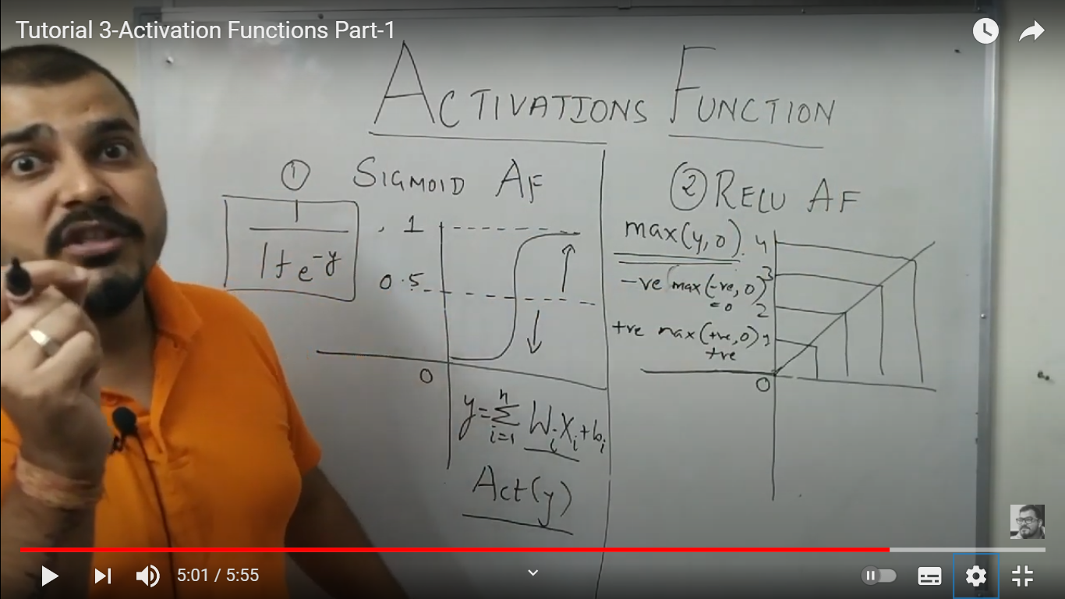

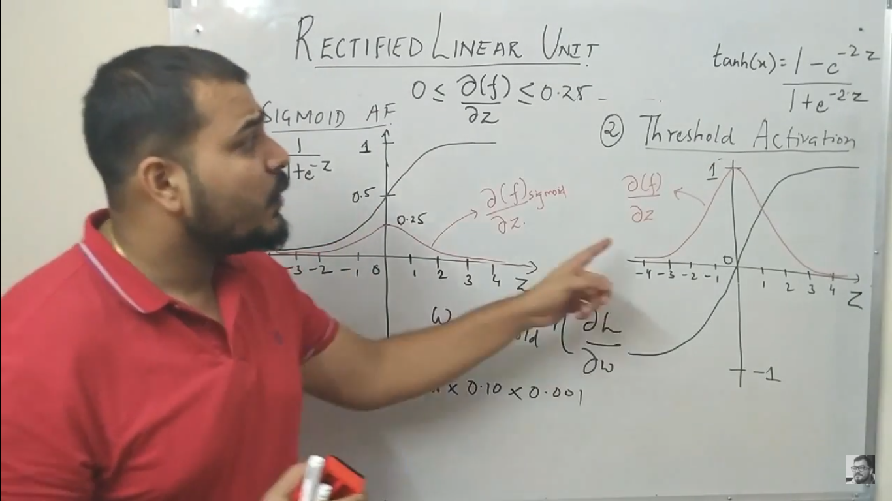

Optimizer : in goig forward and findind the predicted value that doesn’t match with actuall value to reduce this loss we need to change the weights this is called optimer

And we have to back propogated

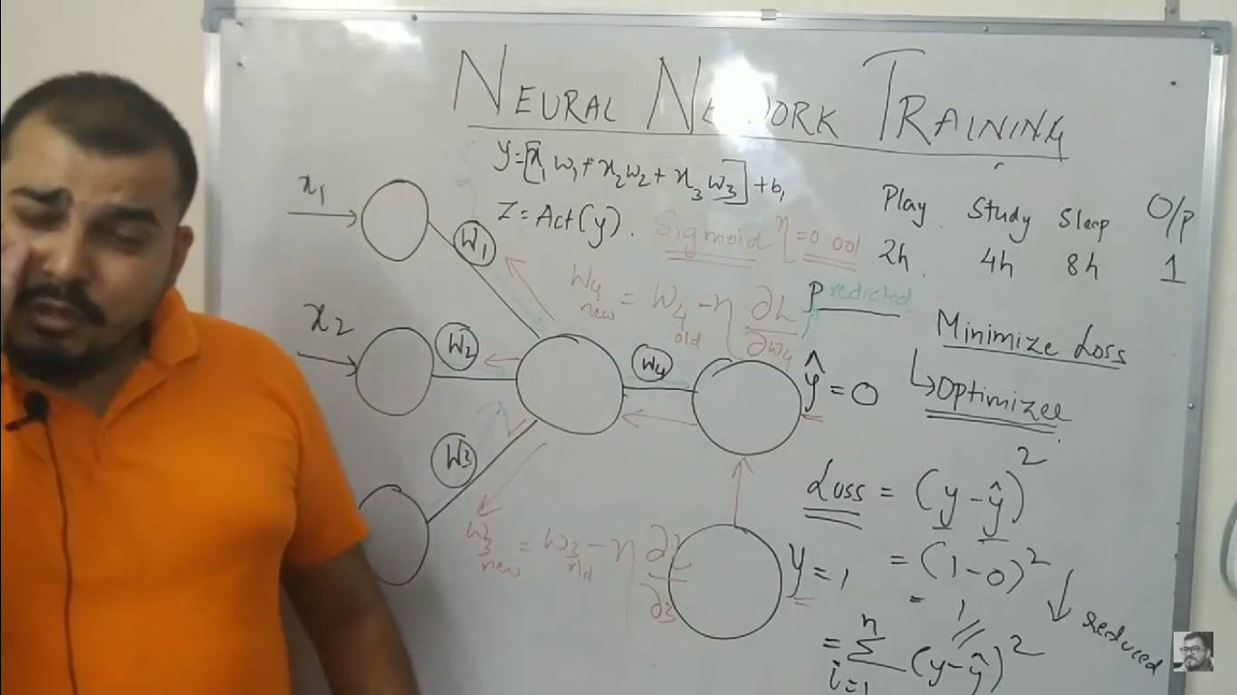

1. Gradient Decent optimizer

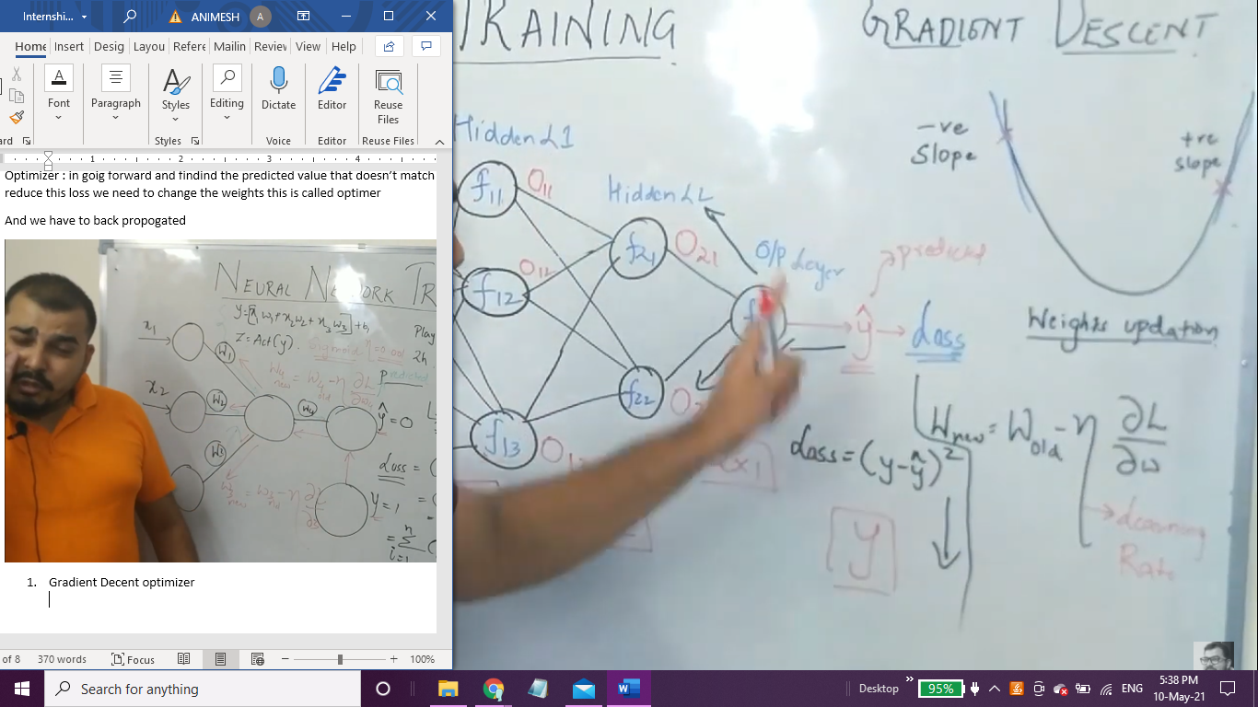

<https://www.youtube.com/watch?v=CRB266Eyjkg>

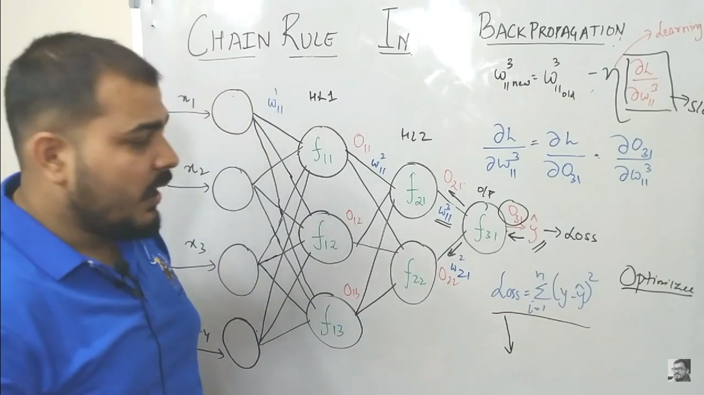

Vanishing gradient problem

It happened because of sigmoid

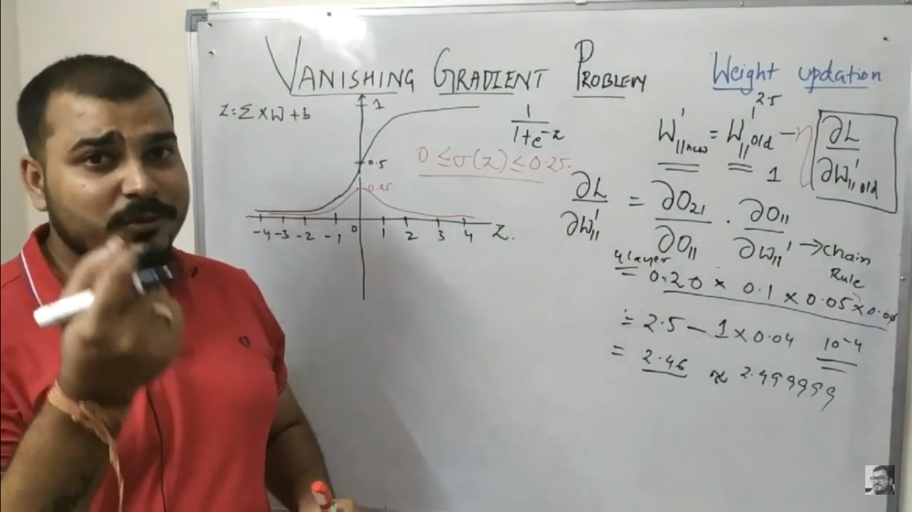

Exploring gradient : In case the weight are higher this problem happes

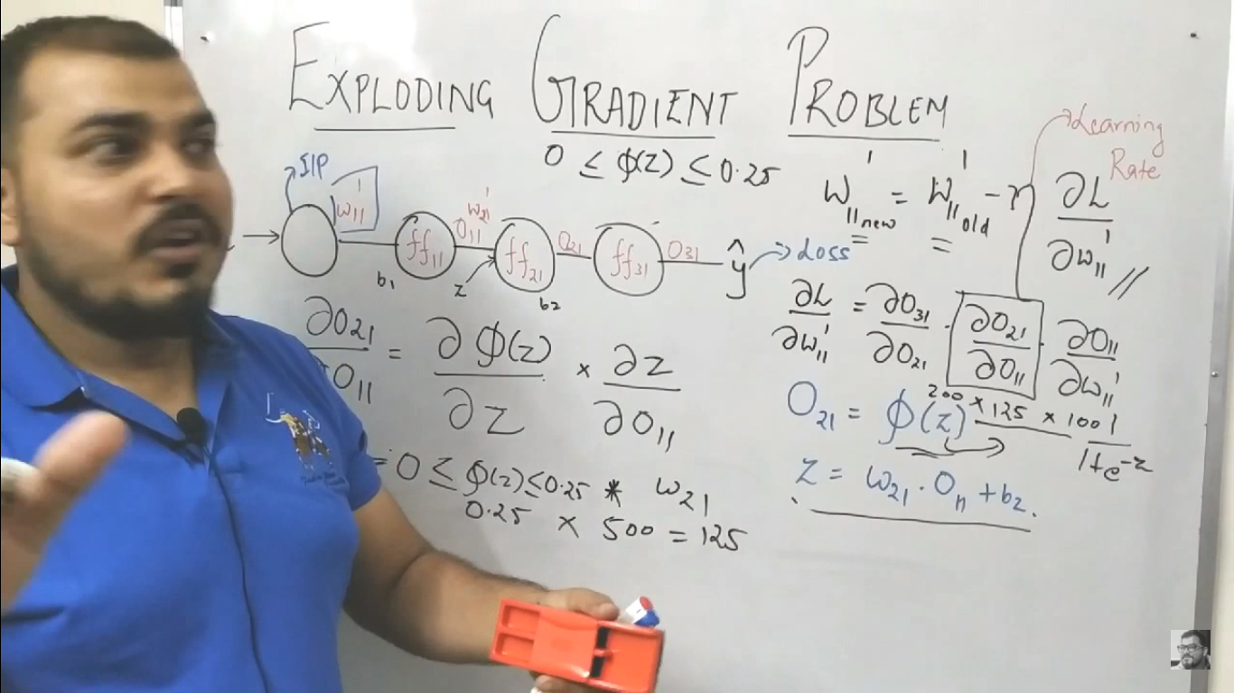

## Overfitting problem

This occurs when there are too many hidden layers

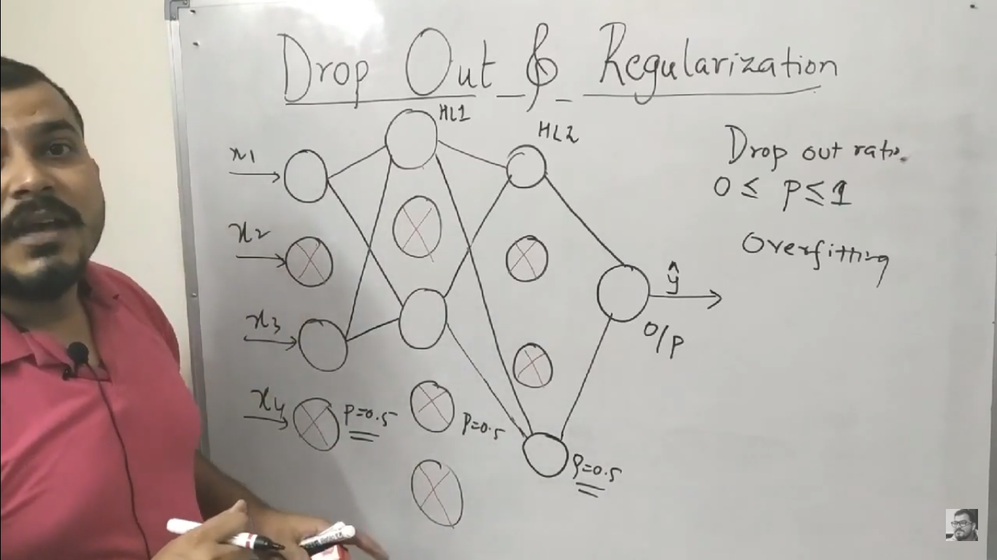

But when it comes to testing all layer are reconnected

Relu has dead neuron problem as the derative either 1 or 0 so in case of 0 the new and old weight remain same

So we have leaky relu

## Weight inilization

1. Weight should be small
2. Weight should not be same
3. Weight should have good variance

### Techniques

1. Uniform distribution works with sigmoid

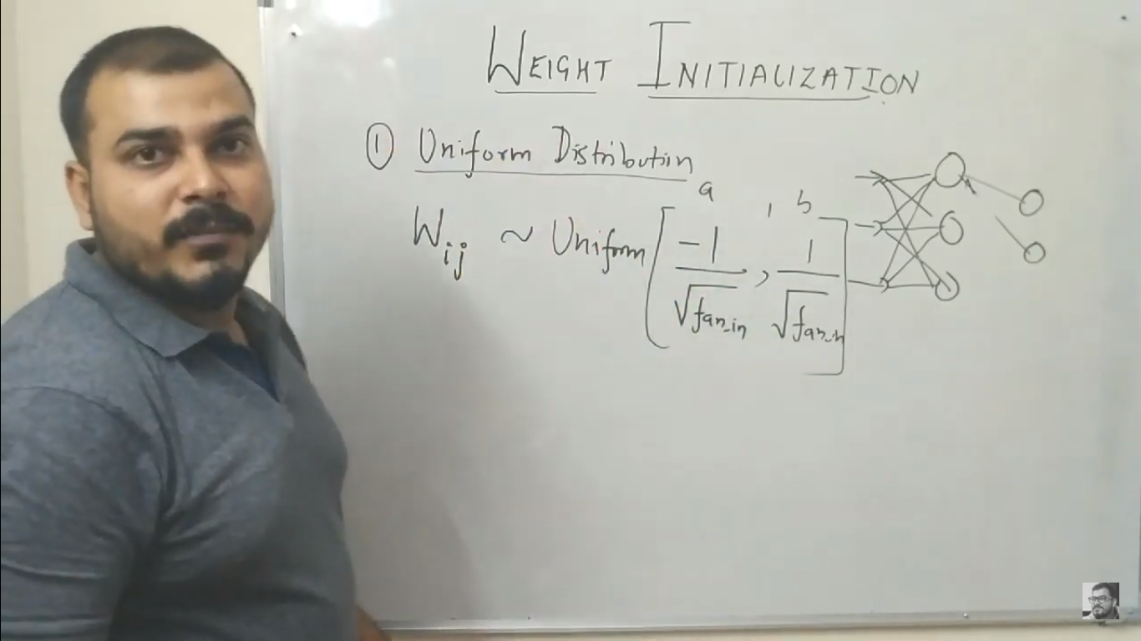

1. Xavier/Gorat

works with sigmoid

1. He int(Relu)

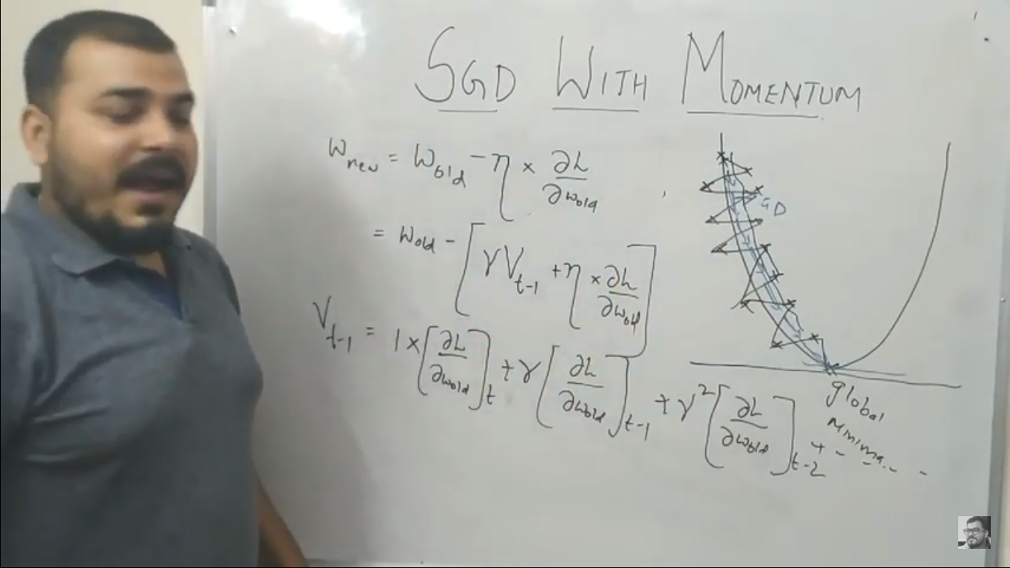

## Optimizer

1. Adgrad

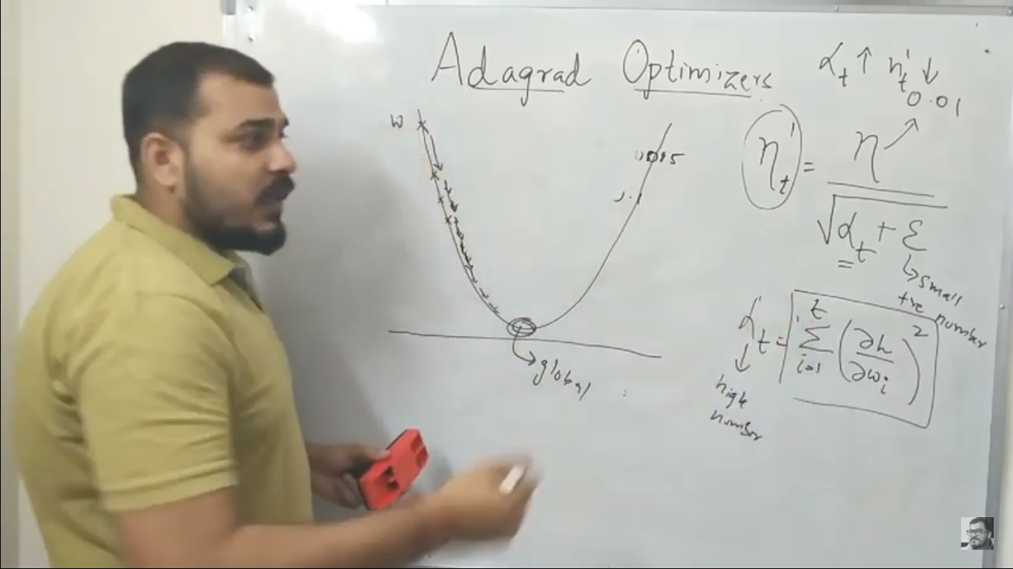

1. Adadelta

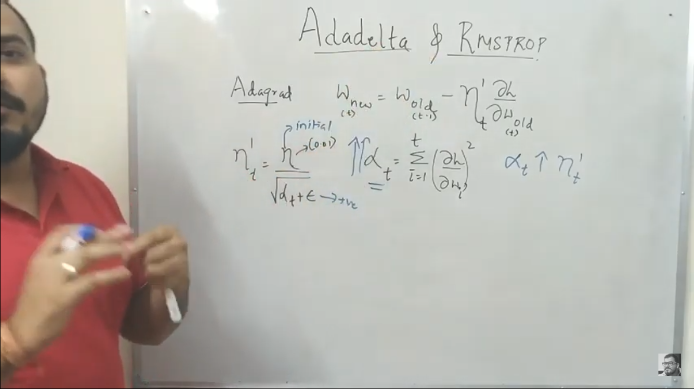

First ANN

<https://colab.research.google.com/drive/1pCYIgx6DeJ68pL_y_zaE6FIdVxnCQ0_j>

# RNN

This word good in case of sequence of data in our case Words

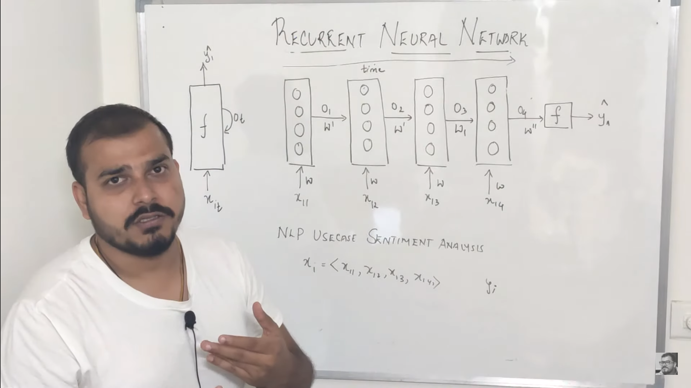

We get o/p wrt time